Chapter 5, Problem 67

Obtain the output v_{o} in the circuit of Fig. 5.94.

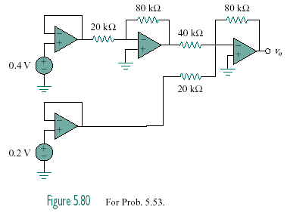

300 mV

700 mV

Figure 5.94
For Prob. 5.67.

